|  |  |  |  |  |  |
| --- | --- | --- | --- | --- | --- |
| Date | 9-Dec-22 | | | Tester Name | Janette Paus |
| Environment | Penfax - Test 2 | | | Login used |  |
| Operating System | Windows | Version: 21H2 | Update Number: | | |
| Software Used | Select Software | Version: 107.0.1418.56 | Update Number: | | |
| Select Software | Version: | Update Number: | | |
| Application Release version | R22.4.1 | | | | |
| Test Case Title | E20.07 | | | | |
| Test Type | Regression | | | | |
| Test Scenario | Backdate a Member Deposit | | | | |
| Expected Results | To process a deposit that has a previous date to it (effective date a previous date). To check the breakage log to ensure it shows on the report and is reasonable.  To confirm that the unit values used in the deposit were the ones on the effective date (not the process date) and that the member was credited the funds/units correctly | | | | |
| Pass/Fail | Pass | | | JIRA# |  |

Find an active PEPP member (using member search):

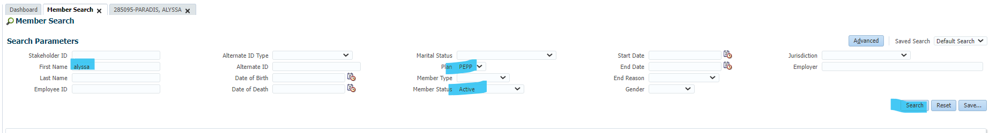

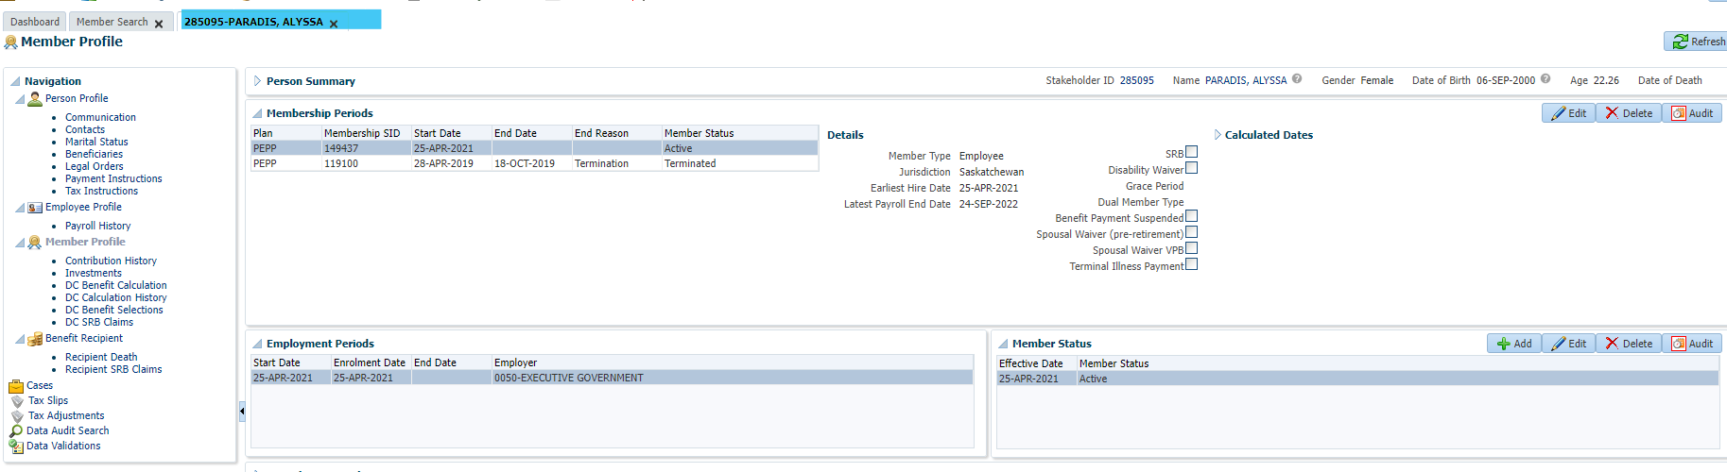

Add remittance:

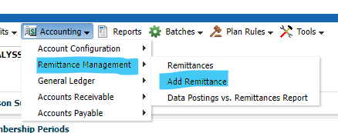

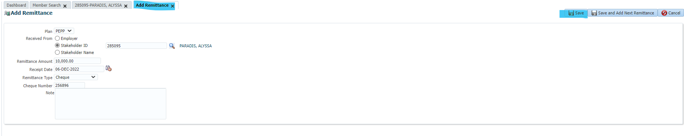

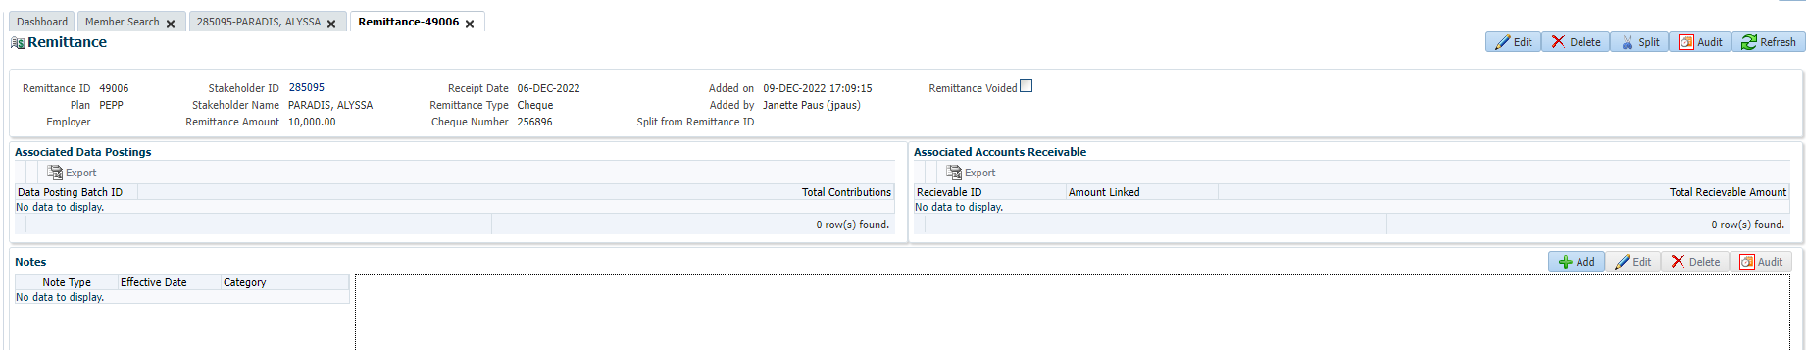

Process Deposit, with effective date in the past:

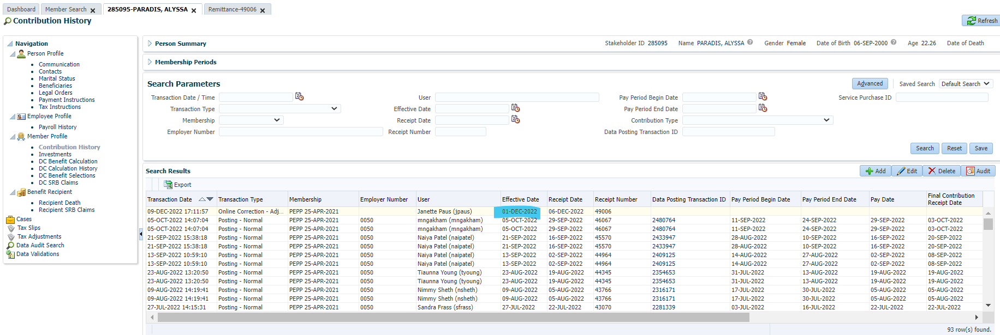

Will check next day to confirm date the funds were deposited, the unit value that was used, and the breakage occurrence.

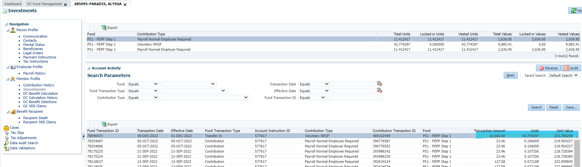

Confirming correct unit values were used in transaction:

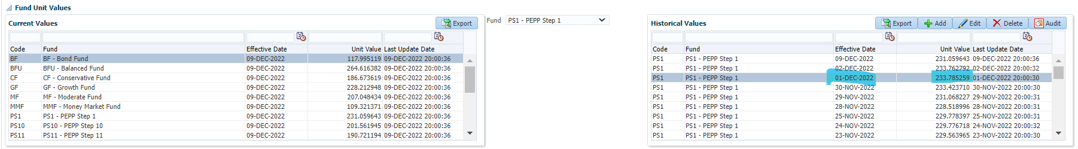

Confirming breakage entry. Unit value today (Dec 9) is 231.059643 (positive breakage makes sense).

